**PART 1 – Schema Database**

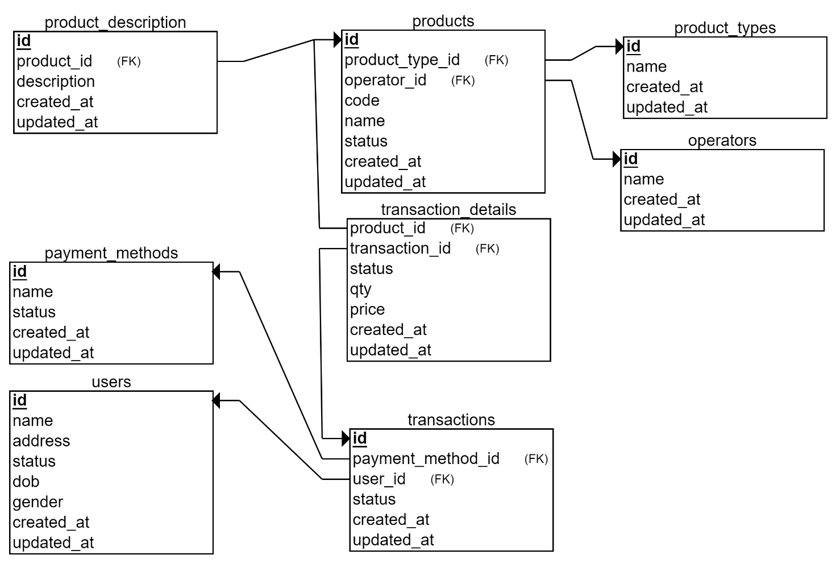

**PART 2 – Data Definition Language**

1. Created Database :

**CREATE** **DATABASE** **IF** **NOT** **EXISTS** `alta_online_shop` */*!40100 DEFAULT CHARACTER SET utf8mb4 */*;

1. Create Table :

**CREATE** **TABLE** users

(

id **INT**(11) **NOT** **NULL** **AUTO_INCREMENT** **NOT** **NULL**,

**name** **VARCHAR**(255) **NOT** **NULL**,

address **VARCHAR**(255) **NOT** **NULL**,

dob **DATE** **NOT** **NULL**,

**status** **SMALLINT** **NOT** **NULL**,

gender **CHAR**(1) **NOT** **NULL**,

created_at **DATETIME** **NOT** **NULL** **DEFAULT** **current_timestamp**(),

updated_at **DATETIME** **NULL** **DEFAULT** **NULL** **ON** **UPDATE** **current_timestamp**(),

**PRIMARY** **KEY** (id)

);

**CREATE** **TABLE** product_types

(

id **INT**(11) **NOT** **NULL** **AUTO_INCREMENT** **NOT** **NULL**,

**name** **VARCHAR**(255) **NOT** **NULL**,

created_at **DATETIME** **NOT** **NULL** **DEFAULT** **current_timestamp**(),

updated_at **DATETIME** **NULL** **DEFAULT** **NULL** **ON** **UPDATE** **current_timestamp**(),

**PRIMARY** **KEY** (id)

);

**CREATE** **TABLE** operators

(

id **INT**(11) **NOT** **NULL** **AUTO_INCREMENT** **NOT** **NULL**,

**name** **VARCHAR**(255) **NOT** **NULL**,

created_at **DATETIME** **NOT** **NULL** **DEFAULT** **current_timestamp**(),

updated_at **DATETIME** **NULL** **DEFAULT** **NULL** **ON** **UPDATE** **current_timestamp**(),

**PRIMARY** **KEY** (id)

);

**CREATE** **TABLE** payment_methods

(

id **INT**(11) **NOT** **NULL** **AUTO_INCREMENT** **NOT** **NULL**,

**name** **VARCHAR**(255) **NOT** **NULL**,

**status** **SMALLINT** **NOT** **NULL**,

created_at **DATETIME** **NOT** **NULL** **DEFAULT** **current_timestamp**(),

updated_at **DATETIME** **NULL** **DEFAULT** **NULL** **ON** **UPDATE** **current_timestamp**(),

**PRIMARY** **KEY** (id)

);

**CREATE** **TABLE** products

(

id **INT**(11) **NOT** **NULL** **AUTO_INCREMENT**,

product_type_id **INT**(11) **NOT** **NULL**,

operator_id **INT**(11) **NOT** **NULL**,

**code** **VARCHAR**(50) **NOT** **NULL**,

**name** **VARCHAR**(100) **NOT** **NULL**,

**status** **SMALLINT** **NOT** **NULL**,

created_at **DATETIME** **NOT** **NULL** **DEFAULT** **current_timestamp**(),

updated_at **DATETIME** **NULL** **DEFAULT** **NULL** **ON** **UPDATE** **current_timestamp**(),

**PRIMARY** **KEY** (id),

**FOREIGN** **KEY** (product_type_id) **REFERENCES** product_types(id),

**FOREIGN** **KEY** (operator_id) **REFERENCES** operators(id)

);

**CREATE** **TABLE** transactions

(

id **INT**(11) **NOT** **NULL** **AUTO_INCREMENT**,

user_id **INT**(11) **NOT** **NULL**,

payment_method_id **INT**(11) **NOT** **NULL**,

**status** **VARCHAR**(10) **NOT** **NULL**,

created_at **DATETIME** **NOT** **NULL** **DEFAULT** **current_timestamp**(),

updated_at **DATETIME** **NULL** **DEFAULT** **NULL** **ON** **UPDATE** **current_timestamp**(),

**PRIMARY** **KEY** (id),

**FOREIGN** **KEY** (user_id) **REFERENCES** users(id),

**FOREIGN** **KEY** (payment_method_id) **REFERENCES** payment_methods(id)

);

**CREATE** **TABLE** transaction_details

(

transaction_id **INT**(11) **NOT** **NULL**,

product_id **INT**(11) **NOT** **NULL**,

**status** **VARCHAR**(10) **NOT** **NULL**,

qty **INT** **NOT** **NULL**,

price **FLOAT** **NOT** **NULL**,

created_at **DATETIME** **NOT** **NULL** **DEFAULT** **current_timestamp**(),

updated_at **DATETIME** **NULL** **DEFAULT** **NULL** **ON** **UPDATE** **current_timestamp**(),

**FOREIGN** **KEY** (transaction_id) **REFERENCES** transactions(id),

**FOREIGN** **KEY** (product_id) **REFERENCES** products(id)

);

**CREATE** **TABLE** product_description

(

id **INT**(11) **NOT** **NULL** **AUTO_INCREMENT** **NOT** **NULL**,

product_id **INT**(11) **NOT** **NULL**,

**description** **TEXT** **NOT** **NULL**,

created_at **DATETIME** **NOT** **NULL** **DEFAULT** **current_timestamp**(),

updated_at **DATETIME** **NULL** **DEFAULT** **NULL** **ON** **UPDATE** **current_timestamp**(),

**PRIMARY** **KEY** (id),

**FOREIGN** **KEY** (product_id) **REFERENCES** products(id)

);

1. Create Tabel Kurir :

**CREATE** **TABLE** `kurir` (

`id` **INT**(11) **NOT** **NULL** **AUTO_INCREMENT**,

`name` **VARCHAR**(50) **NOT** **NULL** **DEFAULT** '0' **COLLATE** 'utf8mb4_general_ci',

`created_at` **DATETIME** **NOT** **NULL** **DEFAULT** **current_timestamp**(),

`updated_at` **DATETIME** **NULL** **DEFAULT** **NULL** **ON** **UPDATE** **current_timestamp**(),

**PRIMARY** **KEY** (`id`) **USING** **BTREE**

)

**COLLATE**='utf8mb4_general_ci'

**ENGINE**=**InnoDB**

;

1. Tambah Kolom Onkgos Dasar di Tabel Kurir :

**ALTER** **TABLE** `kurir`

**ADD** **COLUMN** `ongkos_dasar` **INT** **NOT** **NULL** **DEFAULT** 0 **AFTER** `name`;

1. Ubah nama tabel kurir ke shipping :

**RENAME** **TABLE** `kurir` **TO** `shipping`;

1. Hapus tabel shipping :

**DROP** **TABLE** `shipping`;